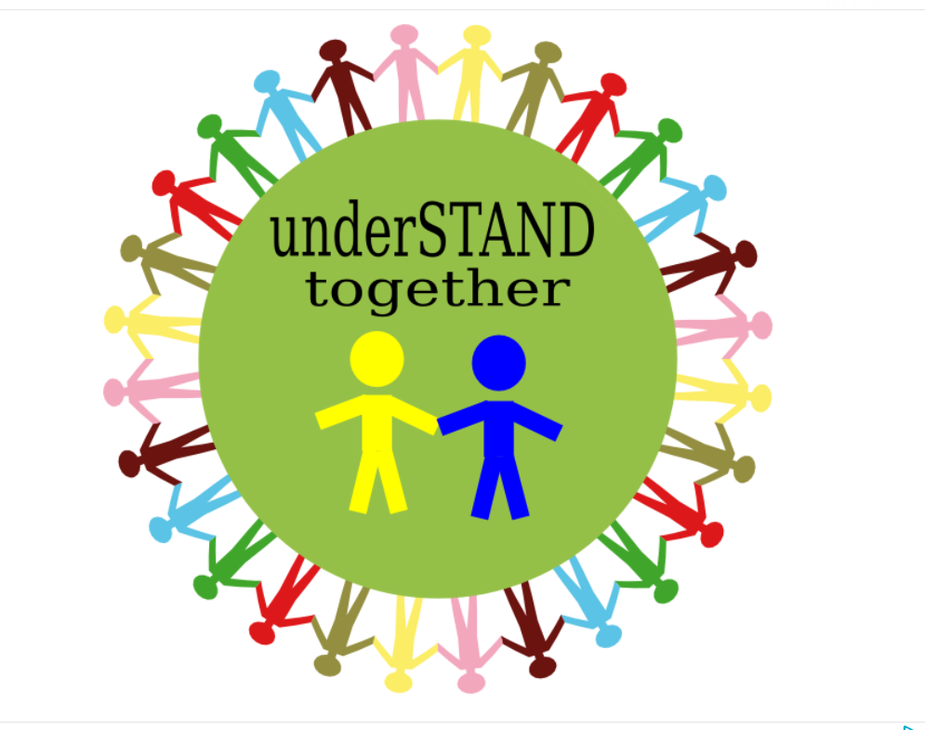
SAYS NO TO BULLYING !
ART AGAINST BULLYING” – proiect Erasmus + cu nr. 2019-1-PL01-KA201-065722
pagina de proiect http://art-against-bullying.eu/.
https://www.facebook.com/Art-Against-Bullying-110990840423132/
